ZOOM CHEAT SHEET

How to Mute Yourself and Start your Camera:
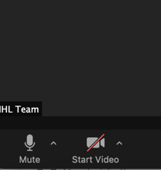
- In the bottom left hand corner of the Zoom screen there is the mute and start video button. If either of them has a red slash through them (such as the video in this screenshot) you are on mute or do not have your camera on.
- Judges and team members should be muted at all times, unless they are speaking, or about to speak. Please ensure you are being respectful to your team members, the other team, and the judges. Remember the judges are playing a role, so will likely interrupt you at some point.
- Bailiffs should stay on mute after they have said the opening remarks and will come off mute when time is up, while allowing the person speaking to finish their sentence.
- Observers and coaches should be on mute and off camera at all times.

How to Change Your Name:
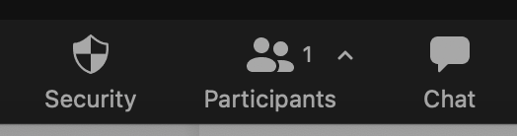
- There are a few ways to change your name, but the simplest is clicking the participants button on the bottom of the zoom screen. This will open up a window on the right, as shown below, and you can then hover over your name, click “more” and then it will open a drop down menu, where you can select rename.

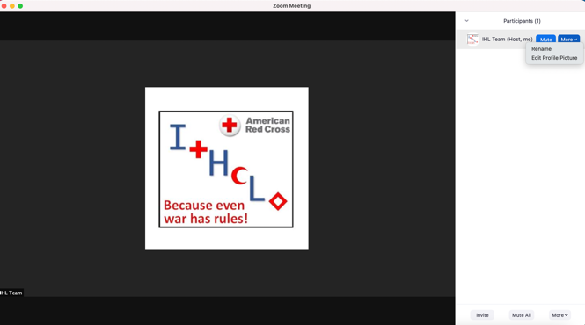

- Team Members: Please change your name to the role you are playing, followed by your First Name for the competition rounds. When you enter the main zoom and have not been placed into your preparation rooms yet, your first name is fine.
- Judges: Please also change your name to the role you are playing. You may include your first name if you wish.
- Bailiffs: Please change your name to Bailiff, First Name.
- Coaches: Please change your name to Coach of School Name.
- Observers: Please change your name to Observer, First Name, School you are affiliated with.
- Red Cross Team: Will be identified by Red Cross, First Name. These are the people who will be able to assist you with any difficulties throughout the competition.

How to Enter your First Breakout Room

- Once the Organizers have opened the breakout rooms, the screen below will appear.
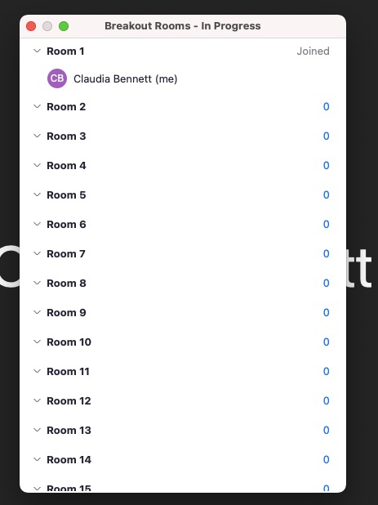

- Then if you hover over the room you are wanting to join, for instance here room 1. You can click the join button, and then the second window will pop up. Press “yes” to be placed in your breakout room.
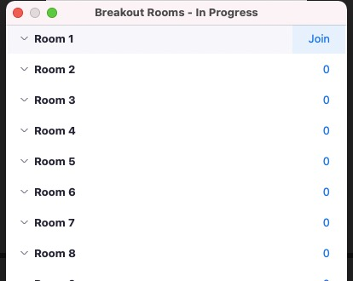

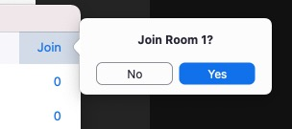

- To leave the breakout room, in the bottom right-hand corner, use the button that says Leave Room or Leave Breakout Room.
- Notes:
  - Do not leave the Meeting between preparation rooms and competition rooms if you are a team member,
  - Do not leave the Meeting between sessions if you are a Judge or a Bailiff.
  - Only leave the Meeting if you have a break; otherwise just leave the Breakout Room and you will be sent to the Main Zoom Room.

How to enter your Second / Third Etc. Breakout Room

- Zoom has a feature where it will want to place you in the same breakout room that you were in before. Due to scheduling and for organizational purposes, most people will not be going to the same room they were in before. So, you will need to dismiss this prompt. (as shown below)
- Then you follow the same steps as above to join the correct breakout room.

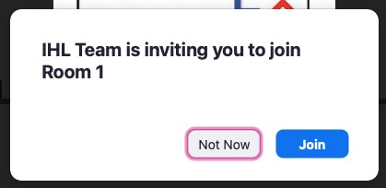

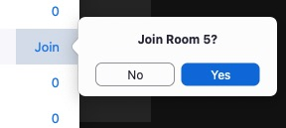

- If at any point you enter the wrong breakout room, you can leave your breakout room and rejoin the correct one.
  - You can do this either through going back to the main Zoom room, or by clicking on the breakout rooms icon and selecting the correct room.

Reminders

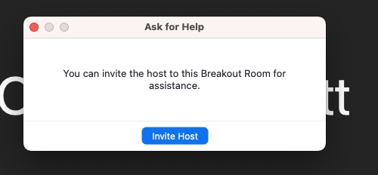
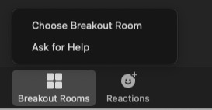
- The chat function will not be used throughout the competition. If you are connected to Zoom, are in your breakout room and having issues, please use the Ask for Help Button as shown in the left screenshot. Then a box will appear on the screen where you can invite the host, as shown in the right screenshot.

- We will NOT be using the screen sharing capabilities or the raise hand function.
- You may change your background if you feel it adds to your role, but please ensure it does not take away from your argument or your role as a judge or bailiff.

